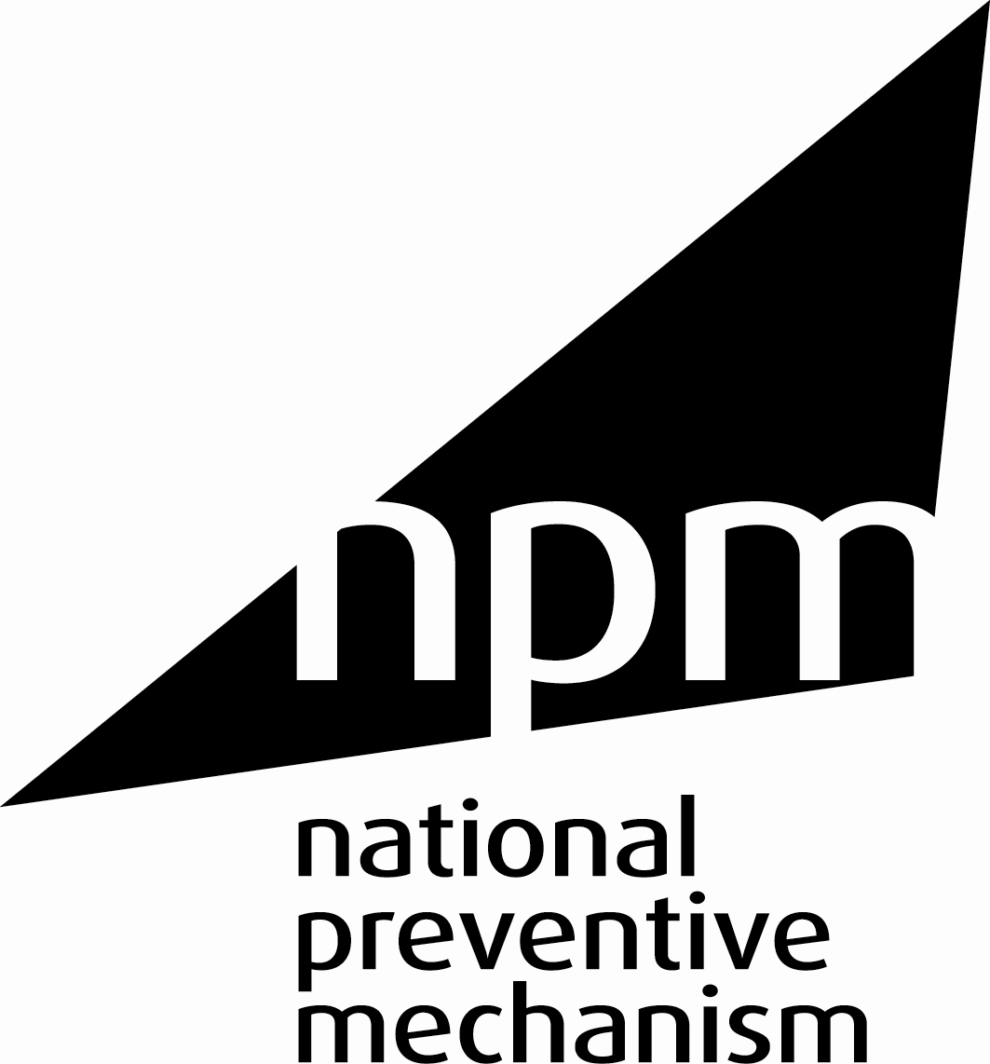

12 May 2016

FOR IMMEDIATE RELEASE

JOHN WADHAM APPOINTED CHAIR
OF THE UK’S NATIONAL PREVENTIVE MECHANISM
The twenty bodies that make up the United Kingdom’s National Preventive Mechanism (NPM) are delighted to announce that John Wadham has agreed to take on the role of NPM chair.
John Wadham is a solicitor with wide experience in the public sector and in the non-government sector. He also has considerable international expertise. Throughout his career, John has worked to protect the rights of detainees.
The UK NPM was established in 2009 to prevent the ill-treatment of anyone deprived of their liberty and to fulfill the UK’s obligations under the Optional Protocol to the United Nations Convention against Torture and Other Cruel, Inhuman or Degrading Treatment or Punishment (OPCAT). The NPM is made up of 20 members from around the UK, all of which monitor the treatment of detainees.
Speaking about his new role, John Wadham said:
“I’m delighted and honoured to have been appointed as the Chair of the NPM, particularly because the appointment was made by the NPM members themselves. The inspection and monitoring bodies provide essential protections for anyone detained anywhere in the UK, many of whom are vulnerable.”
Interim Chair of the UK NPM, and HM Chief Inspector of Prisons for Scotland, David Strang, said:
“The members of the UK NPM warmly welcome John Wadham as our new chair and look forward to working with him.

“John brings invaluable experience as a human rights lawyer with a long-term commitment to safeguarding the rights of detainees.

“A strong independent chair will strengthen the governance of the NPM and enable us to be more effective in our duties to monitor places of detention and to prevent ill treatment.

John has also written a blog for UK Human Rights blog which you can read here.
Notes to editors:
- Read more about the National Preventive Mechanism and its current work on solitary confinement here: http://www.nationalpreventivemechanism.org.uk/
- John Wadham was Chief Legal Officer for the Equality and Human Rights Commission, Deputy Chair of the Independent Police Complaints Commission and most recently the Director of the international human rights organisation, Interights. John has worked with public authorities and politicians across the UK through his work for NGOs and the IPCC and EHRC.
- In 2014, NPM members decided to appoint an independent chair from outside the membership of the NPM to strengthen its governance. The UK NPM is unusual among its counterparts around the world (there are 64 NPMs around the word) in that it is made up of 20 different bodies, so introducing the role of chair is a crucial next step to strengthening the UK's fulfilment of its OPCAT obligations. The chair will represent the UK NPM in meetings with members, government, and international bodies.
- The selection of the NPM chair was made by NPM members through a fair and open recruitment process. The chair will work part time and has been appointed for an initial fixed term of two years. This role is unremunerated though reasonable expenses will be reimbursed.
- NPM members in England and Wales are:
Care Quality Commission
Care and Social Services Inspectorate Wales
Children’s Commissioner for England
Healthcare Inspectorate Wales
HM Inspectorate of Prisons
HM Inspectorate of Constabulary
Independent Monitoring Boards
Independent Custody Visiting Association
Lay Observers
Office for Standards in Education (Ofsted)

- NPM members in Scotland are:
Care Inspectorate
HM Inspectorate of Constabulary for Scotland
HM Inspectorate of Prisons for Scotland
Independent Custody Visitors Scotland
Mental Welfare Commission for Scotland
Scottish Human Rights Commission

- NPM members in Northern Ireland are:
Criminal Justice Inspection Northern Ireland
Independent Monitoring Boards (Northern Ireland)
Northern Ireland Policing Board Independent Custody Visiting Scheme
Regulation and Quality Improvement Authority.

- OPCAT: the Optional Protocol to the United Nations Convention against Torture and Other Cruel, Inhuman or Degrading Treatment or Punishment was created for the protection of persons deprived of their liberty by strengthening systems of regular visits to places of detention. It was ratified by the UK government in 2003 and is now binding on the UK as a matter of international law.
http://www.ohchr.org/EN/ProfessionalInterest/Pages/OPCAT.aspx

- For further information please contact Jane Parsons, HMI Prisons press office, on 020 3681 2775.

